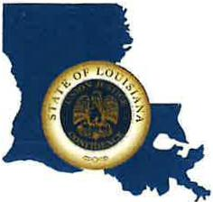 | CAPITAL AREA GROUNDWATER CONSERVATION DISTRICT
GARY I. BEARD
EXECUTIVE DIRECTOR

MEETING NOTICE
Capital Area Groundwater Conservation District
Administrative Committee Meeting

WHEN: Tuesday, December 12, 2023

TIME: 10:00 a.m.

WHERE: Capital Area Groundwater Office
3074 Westfork Dr., Suite A
Baton Rouge, LA 70816

Contact Person: Lisa Manda, (225)293-7370

